# Lab 3 — Lambda to Delete Aged IAM Access Keys
⚠️ Throwaway account, throwaway users only.
1. Create 2–3 test IAM users with access keys.
2. Create a Lambda execution role with only: `iam:ListUsers`, `iam:ListAccessKeys`, `iam:DeleteAccessKey`, plus CloudWatch Logs permissions.
3. Write a Python/boto3 Lambda that:
- paginates through all IAM users
- lists each user's access keys
- compares `CreateDate` against `datetime.now(timezone.utc)`
- flags any key older than `MAX_KEY_AGE_DAYS` (env var)
4. Add a `DRY_RUN` env var, defaulting to `true`. Only delete when explicitly set to `false`.
5. Add an `EXCLUDED_USERS` env var so break-glass accounts are never touched.
6. Skip keys already `Inactive`.
7. Raise the Lambda timeout above the 3-second default.
8. Run in dry-run mode. Read the CloudWatch logs. Verify the list is correct.
9. Flip `DRY_RUN` to `false` and run for real.
10. Schedule it daily with EventBridge: `cron(0 3 * * ? *)`.
11. Optional: publish a summary to SNS so a human hears about it.

**Cleanup:** EventBridge schedule → Lambda → execution role → log group → test IAM users.

Step 1: Create 2-3 IAM users.
IAM --- IAM users --- Enter name --- next --- don’t set any permissions as it not required --- create user
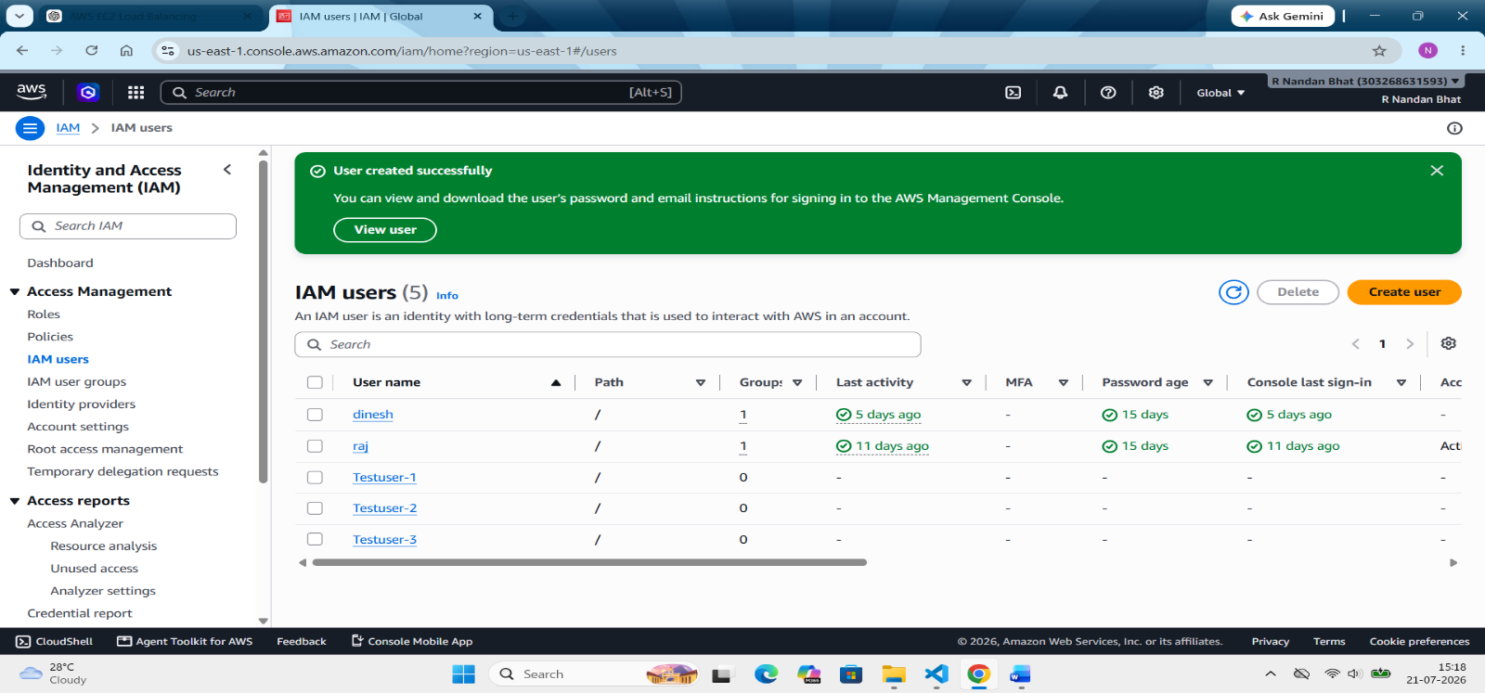
Step 2: Create access keys for the users
IAM --- IAM user --- select the user --- security credentials --- create access keys --- select CLI --- next --- add description (optional) --- create access key
Note: Copy the access key and secret access key and keep it safe for future use.
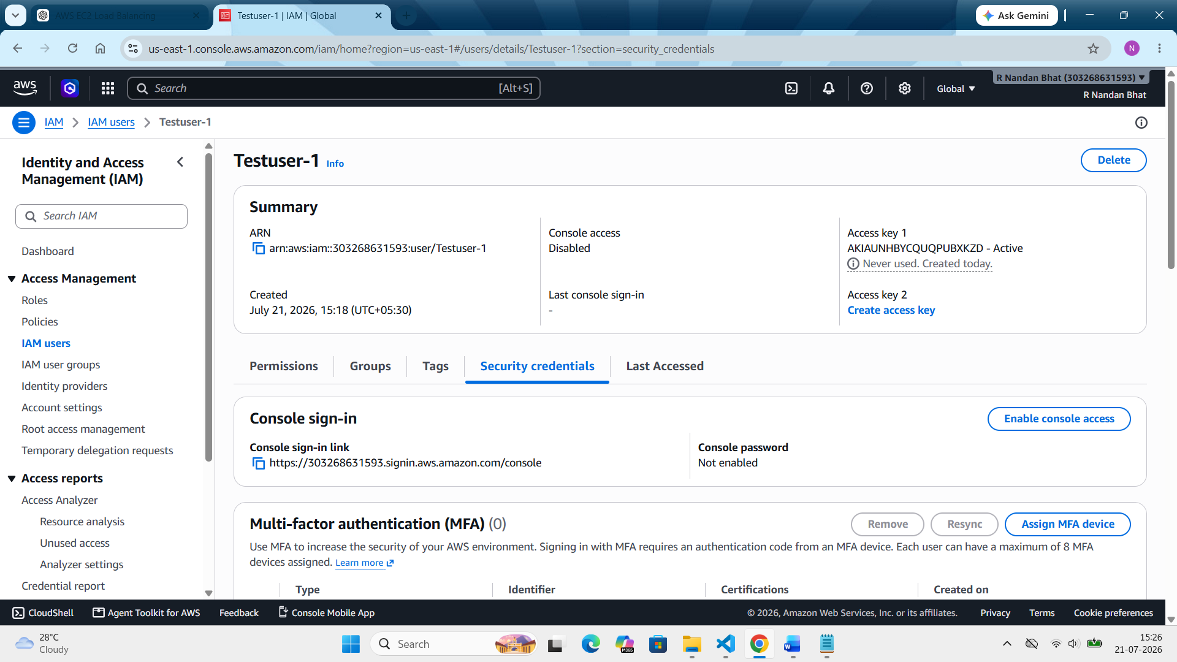
Do the same for testuser 2 and testuser 3.
Step 3: Create the Lambda Execution Role
This role defines what permissions the Lambda function has. The Lambda deletes access keys, not the IAM users themselves. That's why we give permissions to the Lambda execution role.
IAM --- roles --- create role --- trusted entity types (AWS service) --- Use case (lambda) --- create role
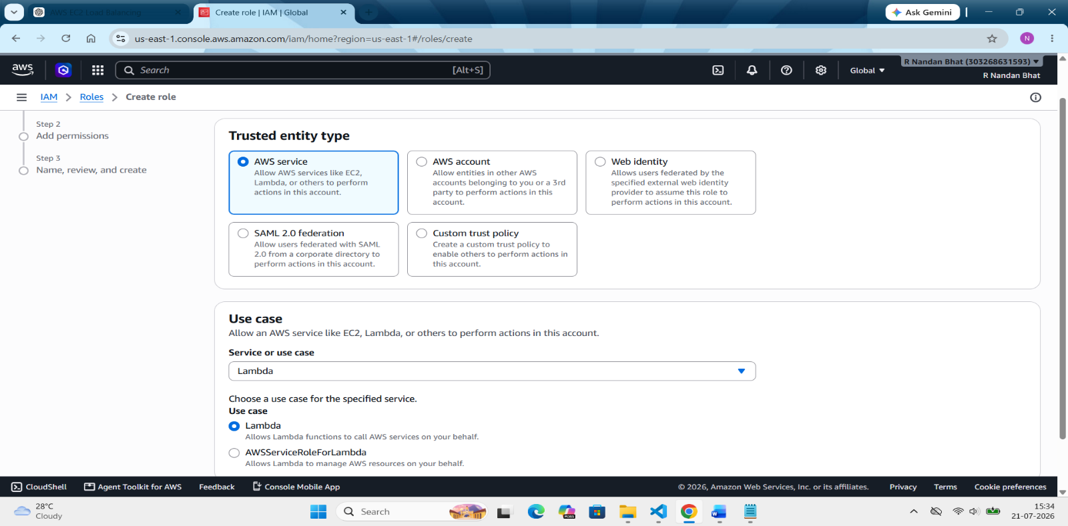
Add permissions --- AWSlambdabasicexecutionrole (permission to write log in cloudwatch) --- create inline policy --- json format --- write the json policy --- add permission for `iam:ListUsers`, `iam:ListAccessKeys`, `iam:DeleteAccessKey`--- next ---create role
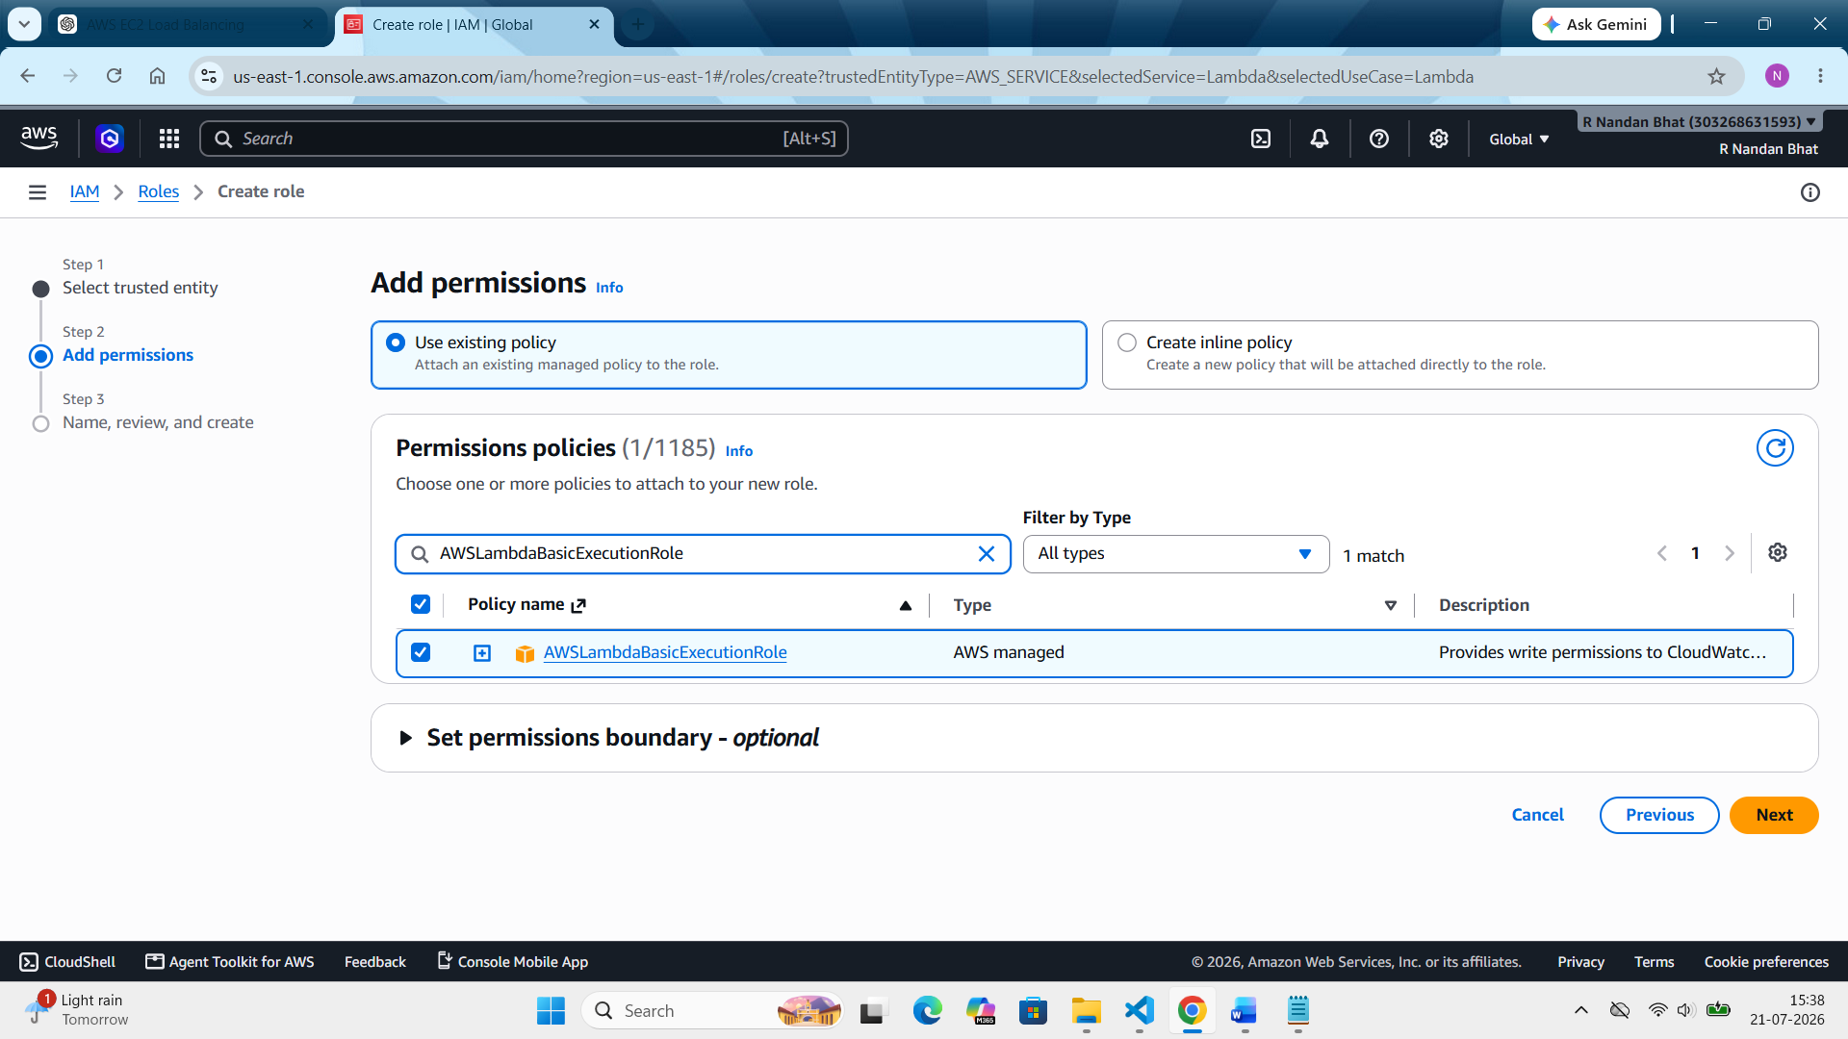

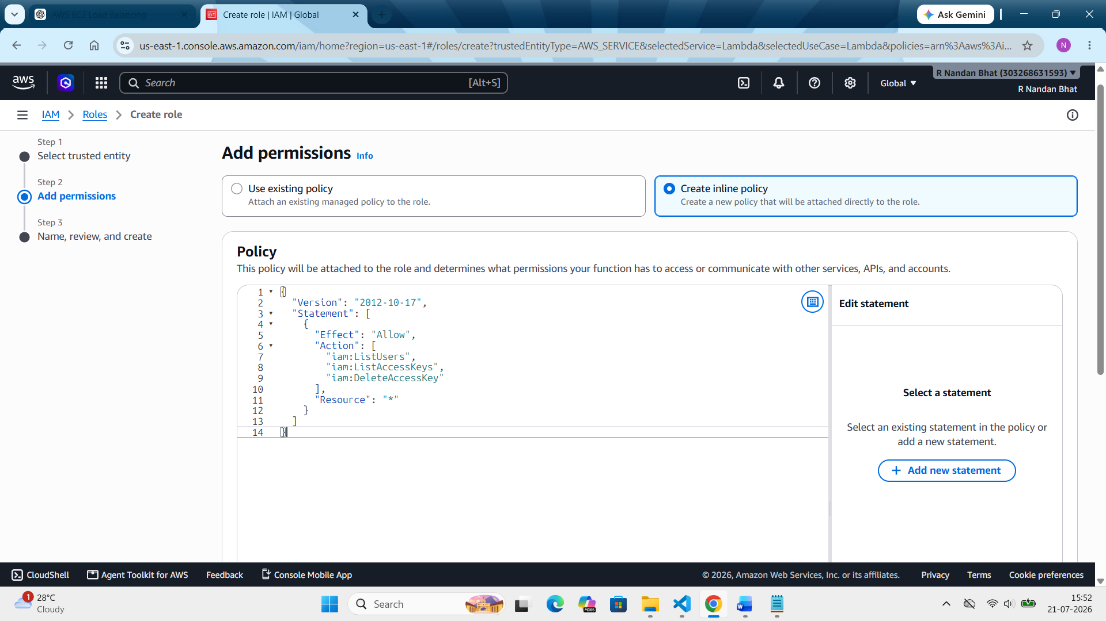

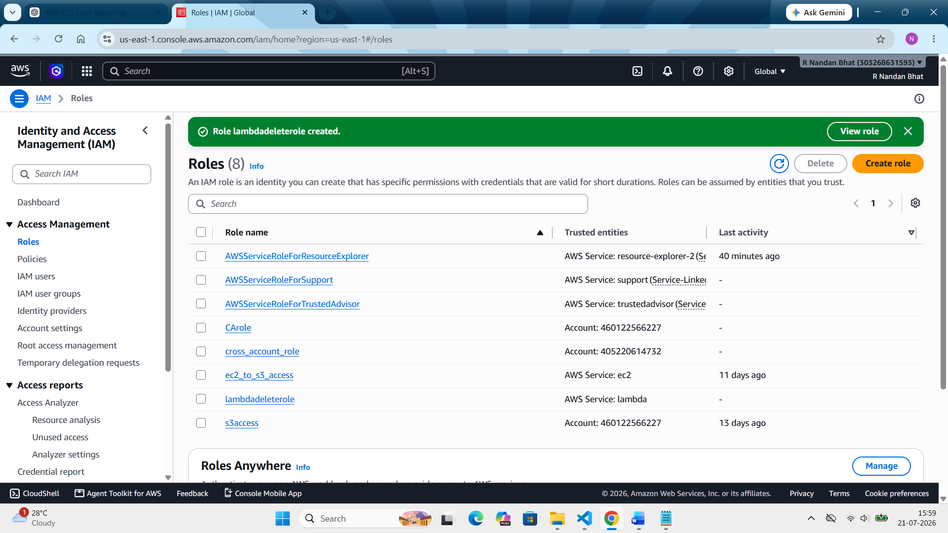

Step 4: Creating lambda function
Lambda --- create function --- create function (create from scratch) --- enter name (lambdadeletefunction) --- choose python (python 3.14) --- additional settings --- custom execution role ---select the created role --- save --- create function
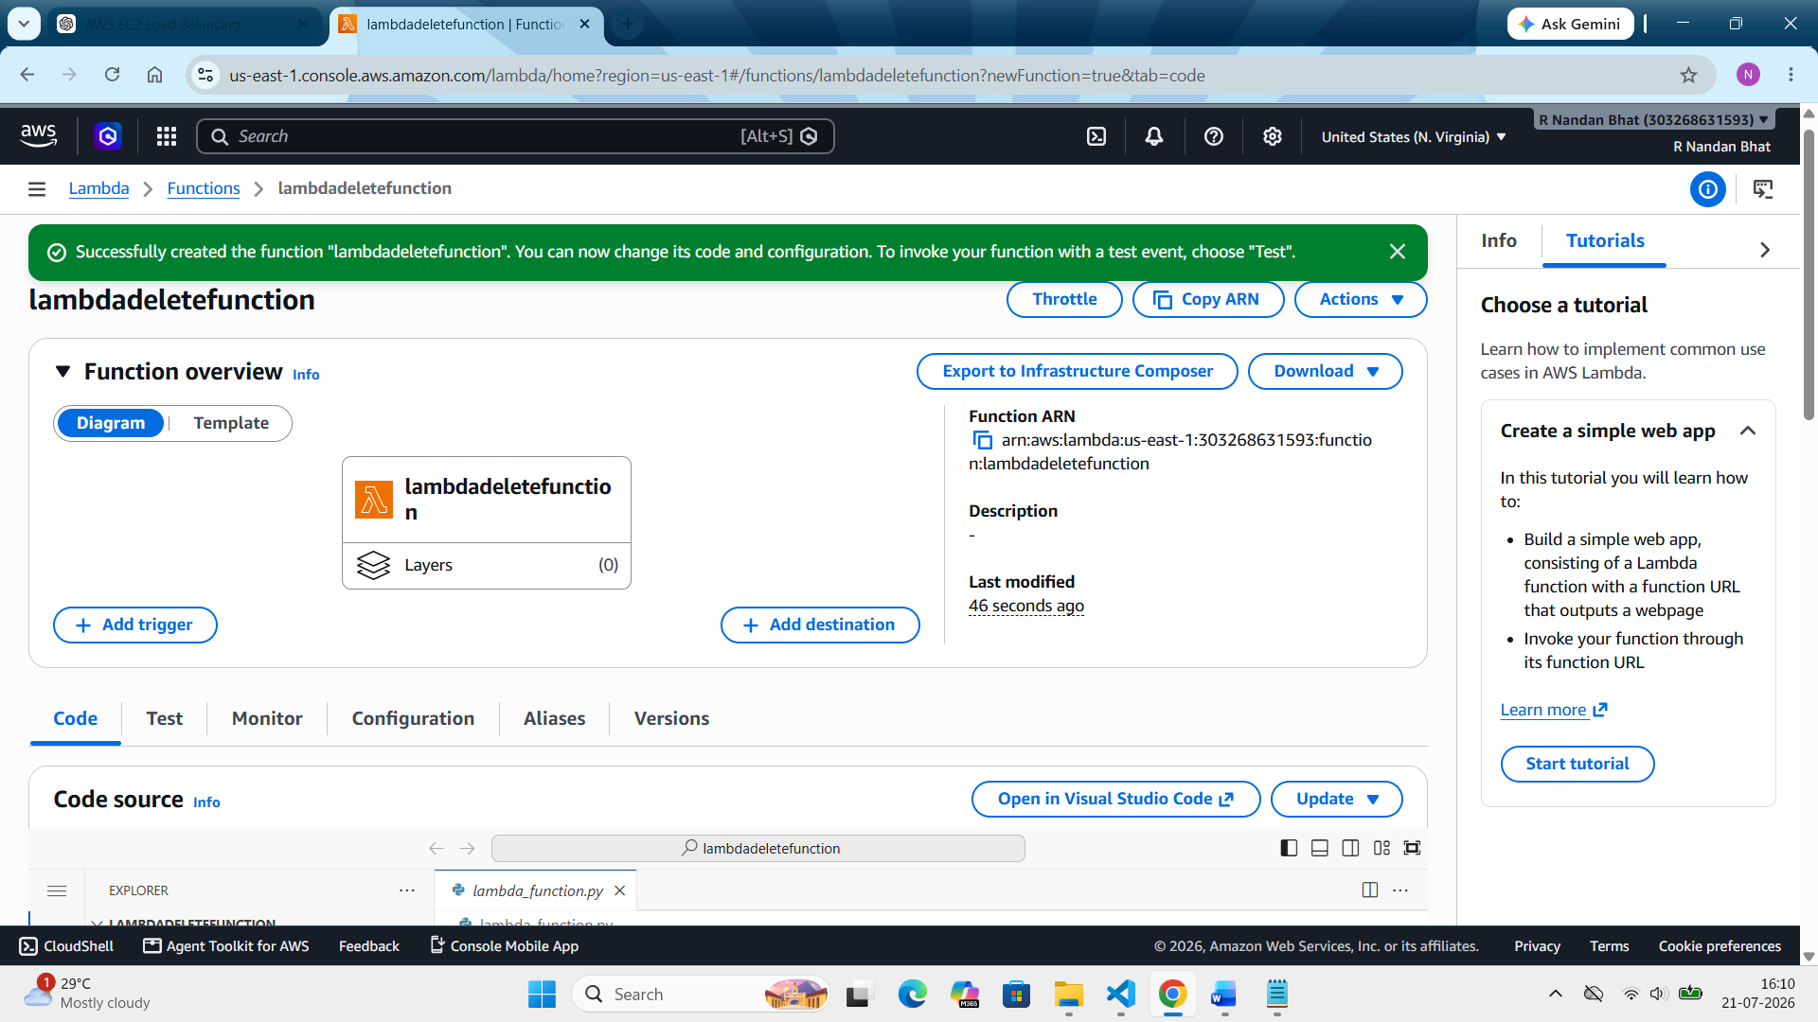

Step 5: Increase the Lambda Timeout
Lambda --- functions --- select your function --- configuration --- edit --- change to the desired time (30 seconds) --- save.
Step 6: Add Environment Variables
Lambda --- function --- select the required function --- environment variables --- edit --- add environment variables --- add
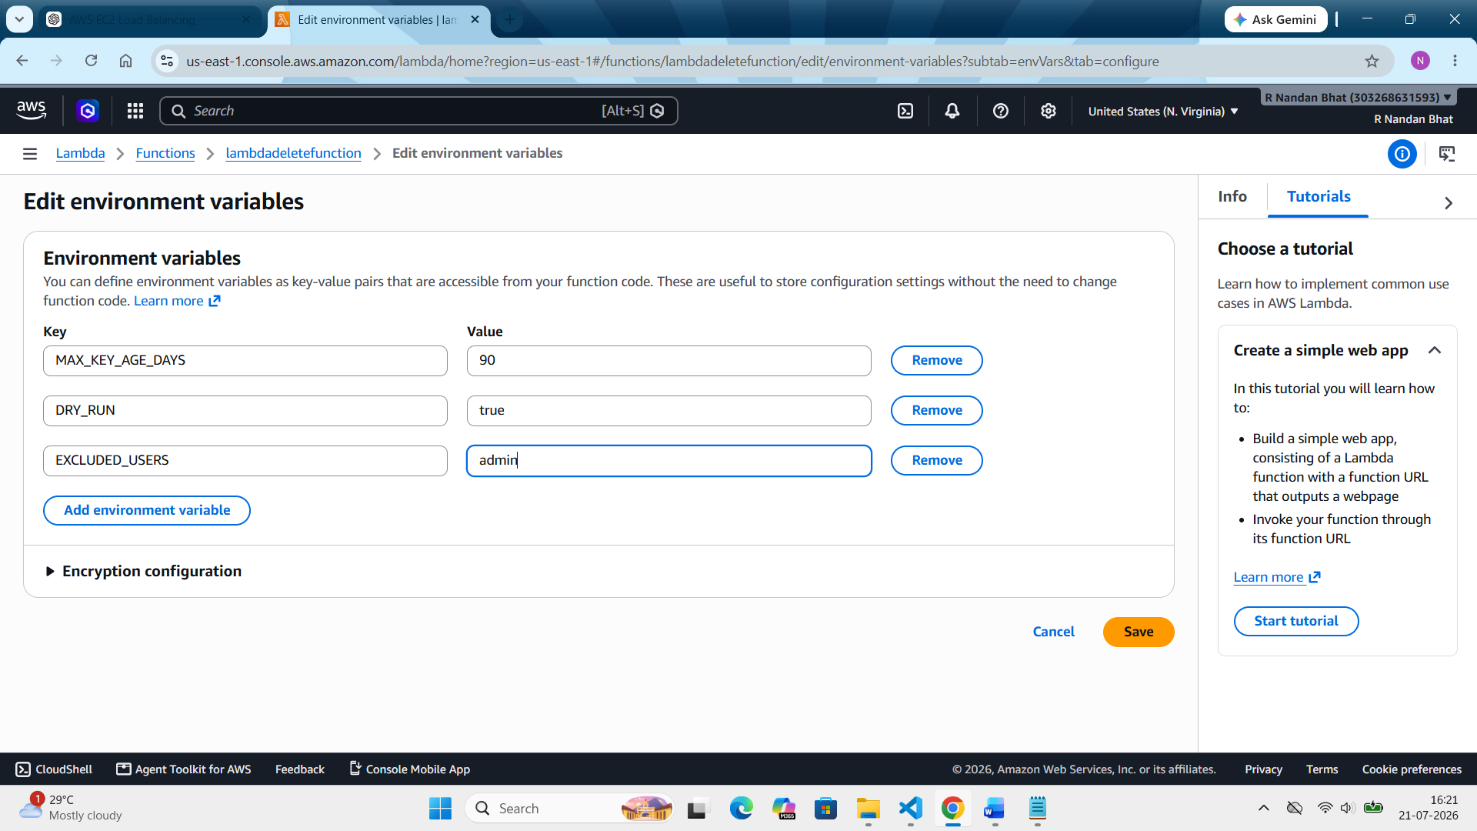

Step 7: Write the lambda code:
AWS console --- Lambda --- function --- select the created function --- code --- in that write the python code in lambda.py --- click on “deploy” ---
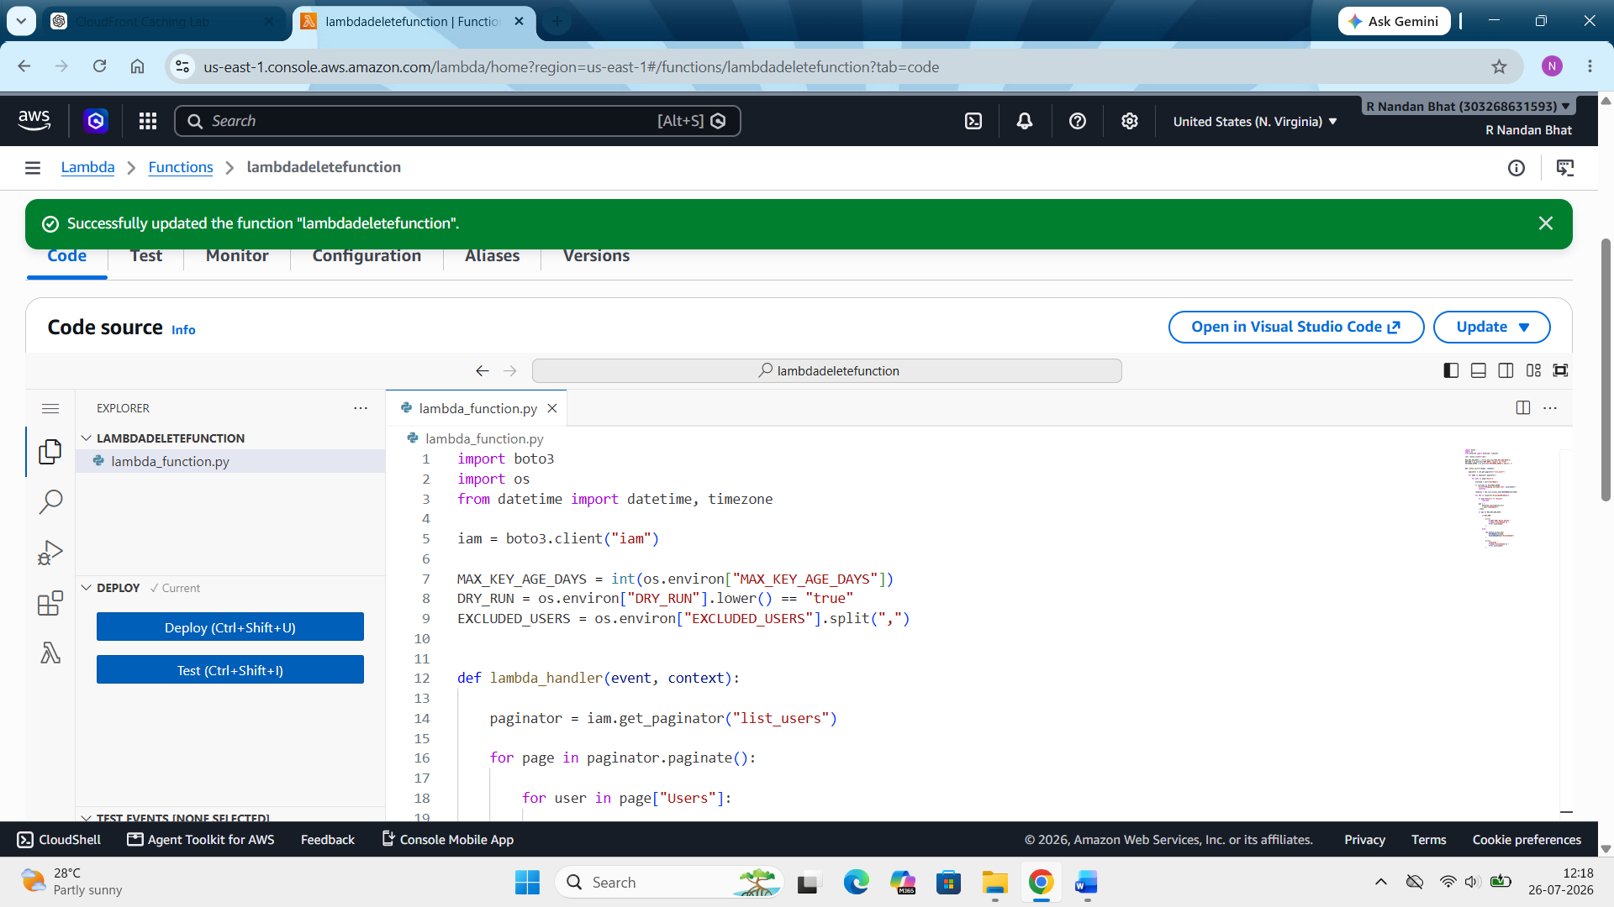
Step 8: Test the Lambda function:
AWS console --- Lambda --- functions --- select created function (lambdadeletefunction) --- test --- create new event --- name it (deleteoldkeytest) --- rest keep everything as it is (default) --- save
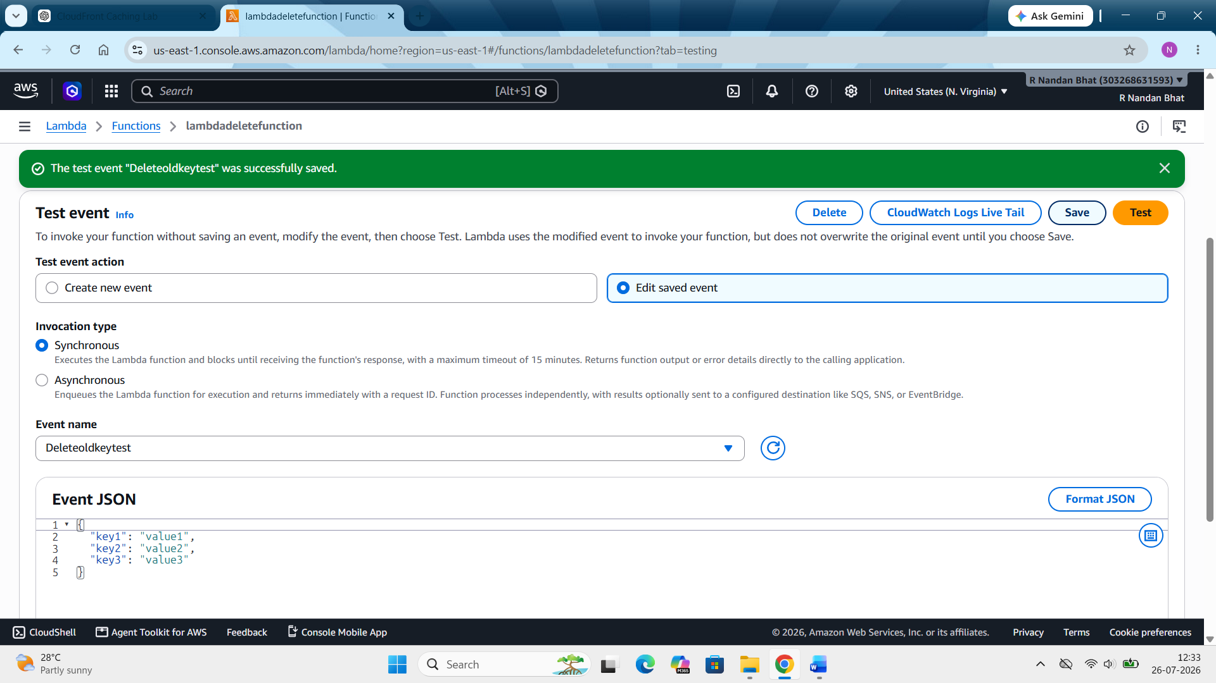

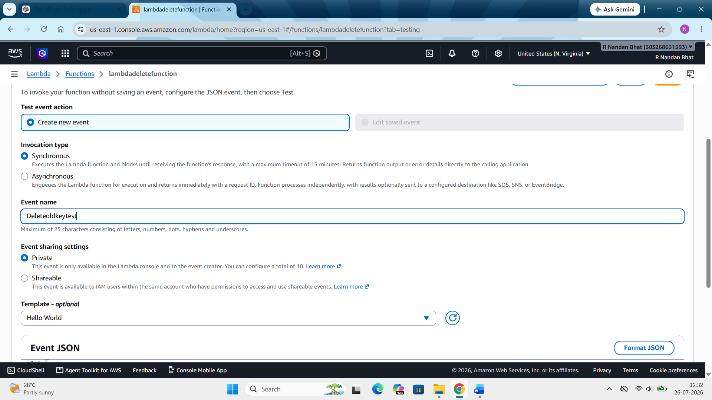

Step 9: Now run the function
Click on the test button on the top right corner.

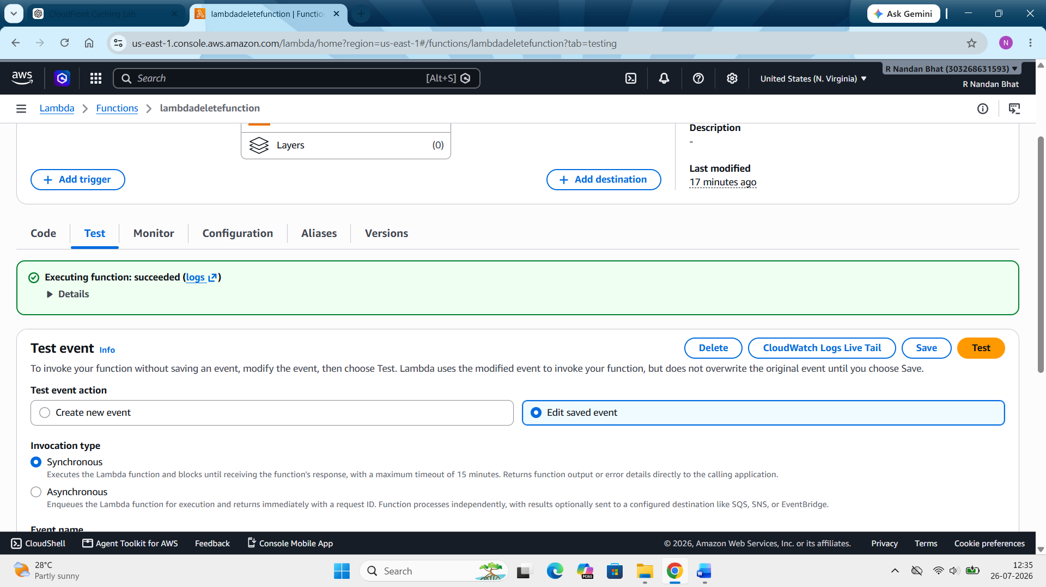

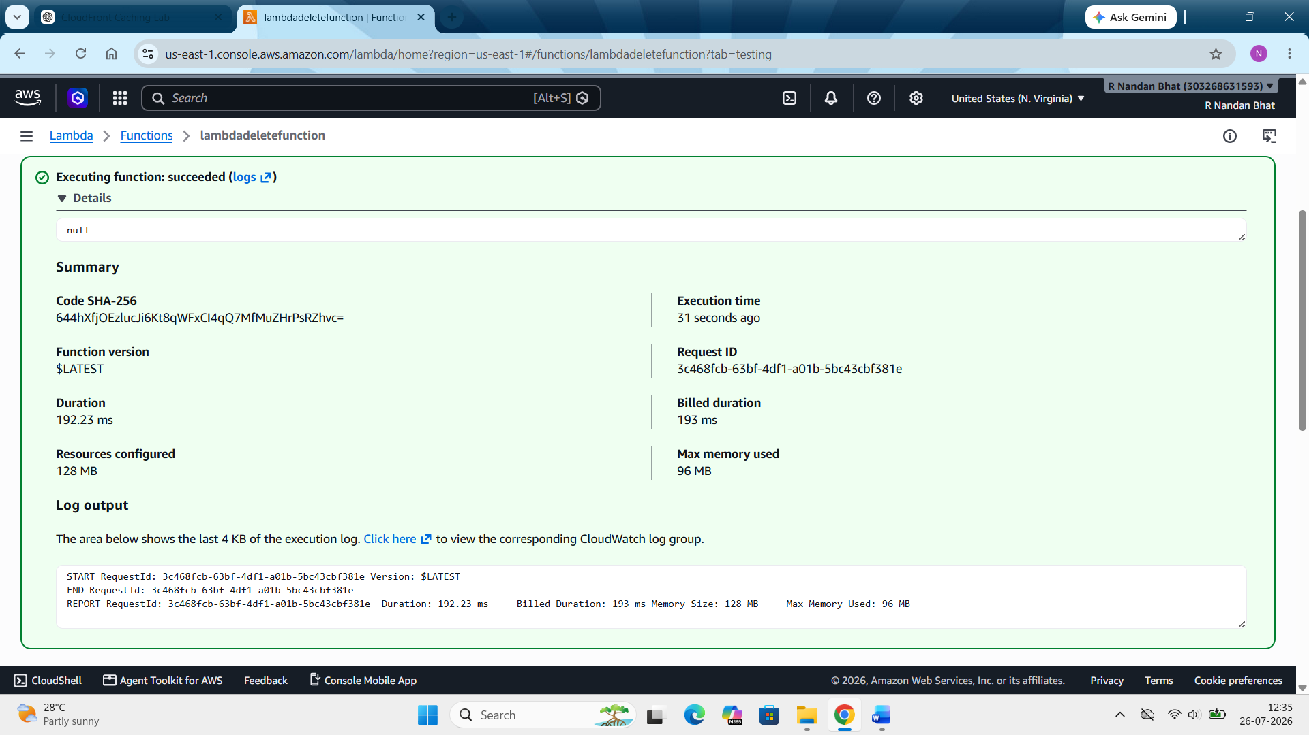
Function has executed successfully. Code ran without crashing.

Step 10: Open cloudwatch logs:
Lambda --- monitor ---view cloudwatch logs --- latest log stream
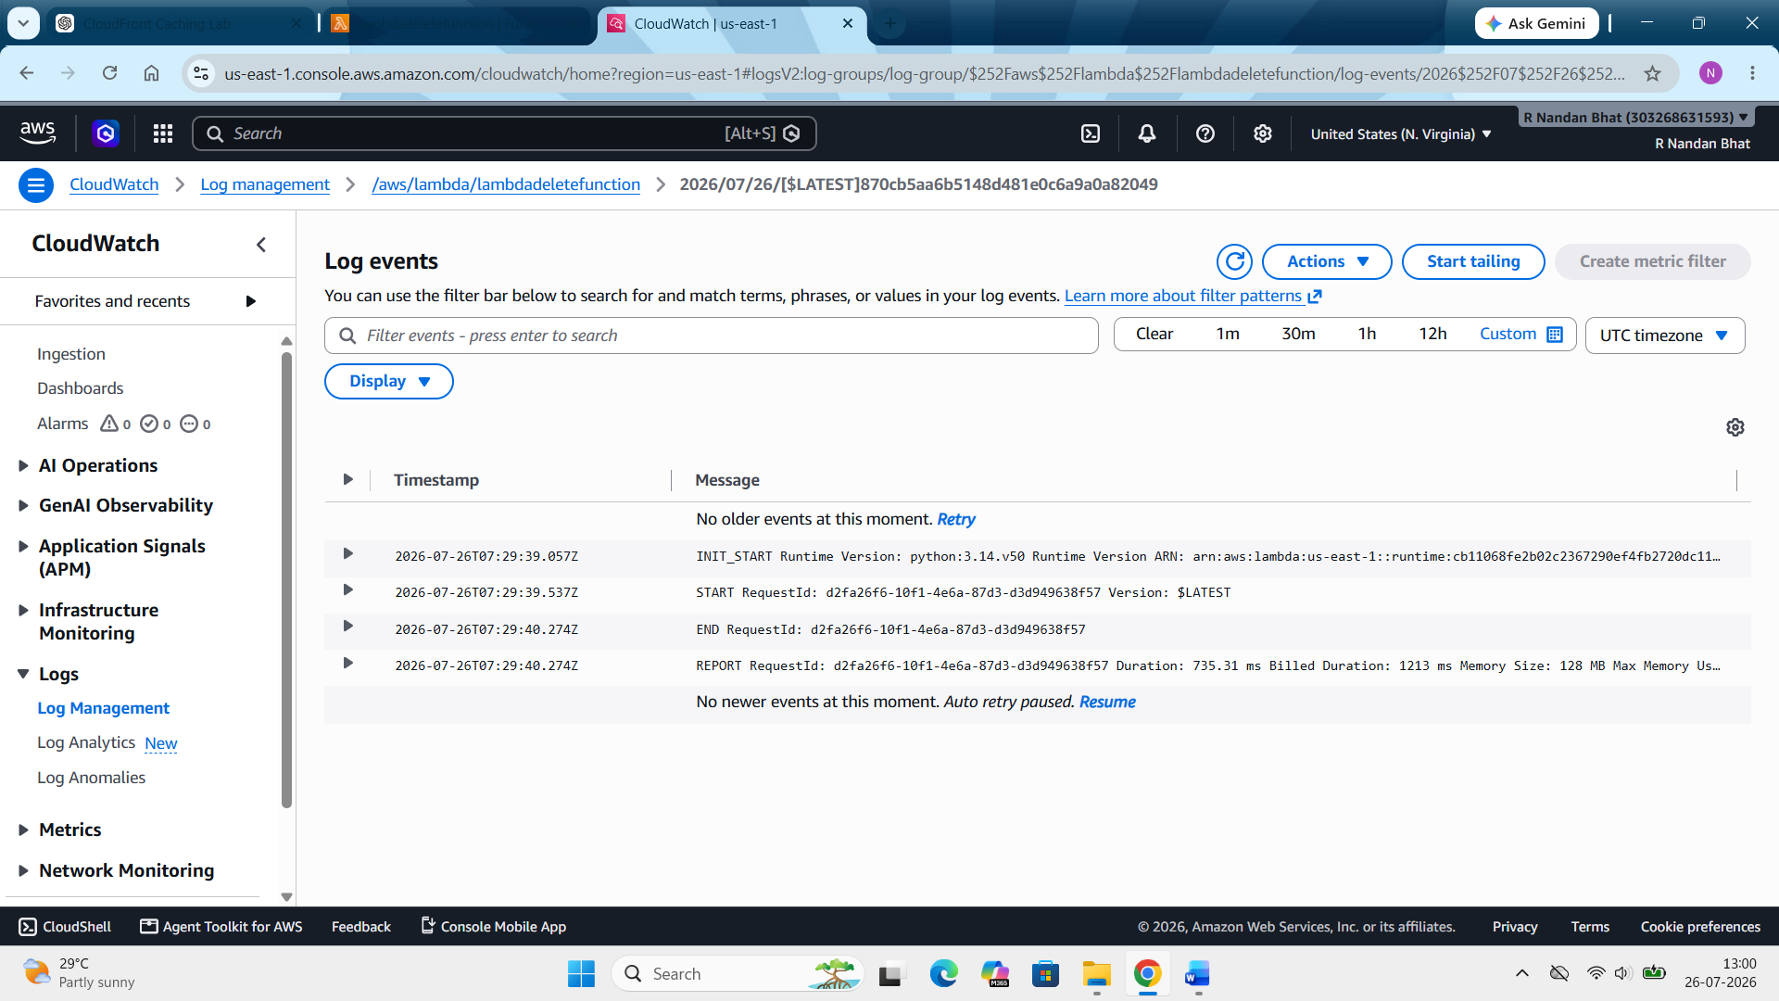

Step 11: Schedule the Lambda using EventBridge
AWS --- event bridge --- scheduler --- schedule --- create schedule --- name the schedule (DeleteoldIAMkeyschedule) --- scheduling pattern (recurring schedule) --- type (cron based schedule) --- in that enter (0 3 * * ? *) --- next --- target type --- aws lambda --- select the created function --- next --- create schedule
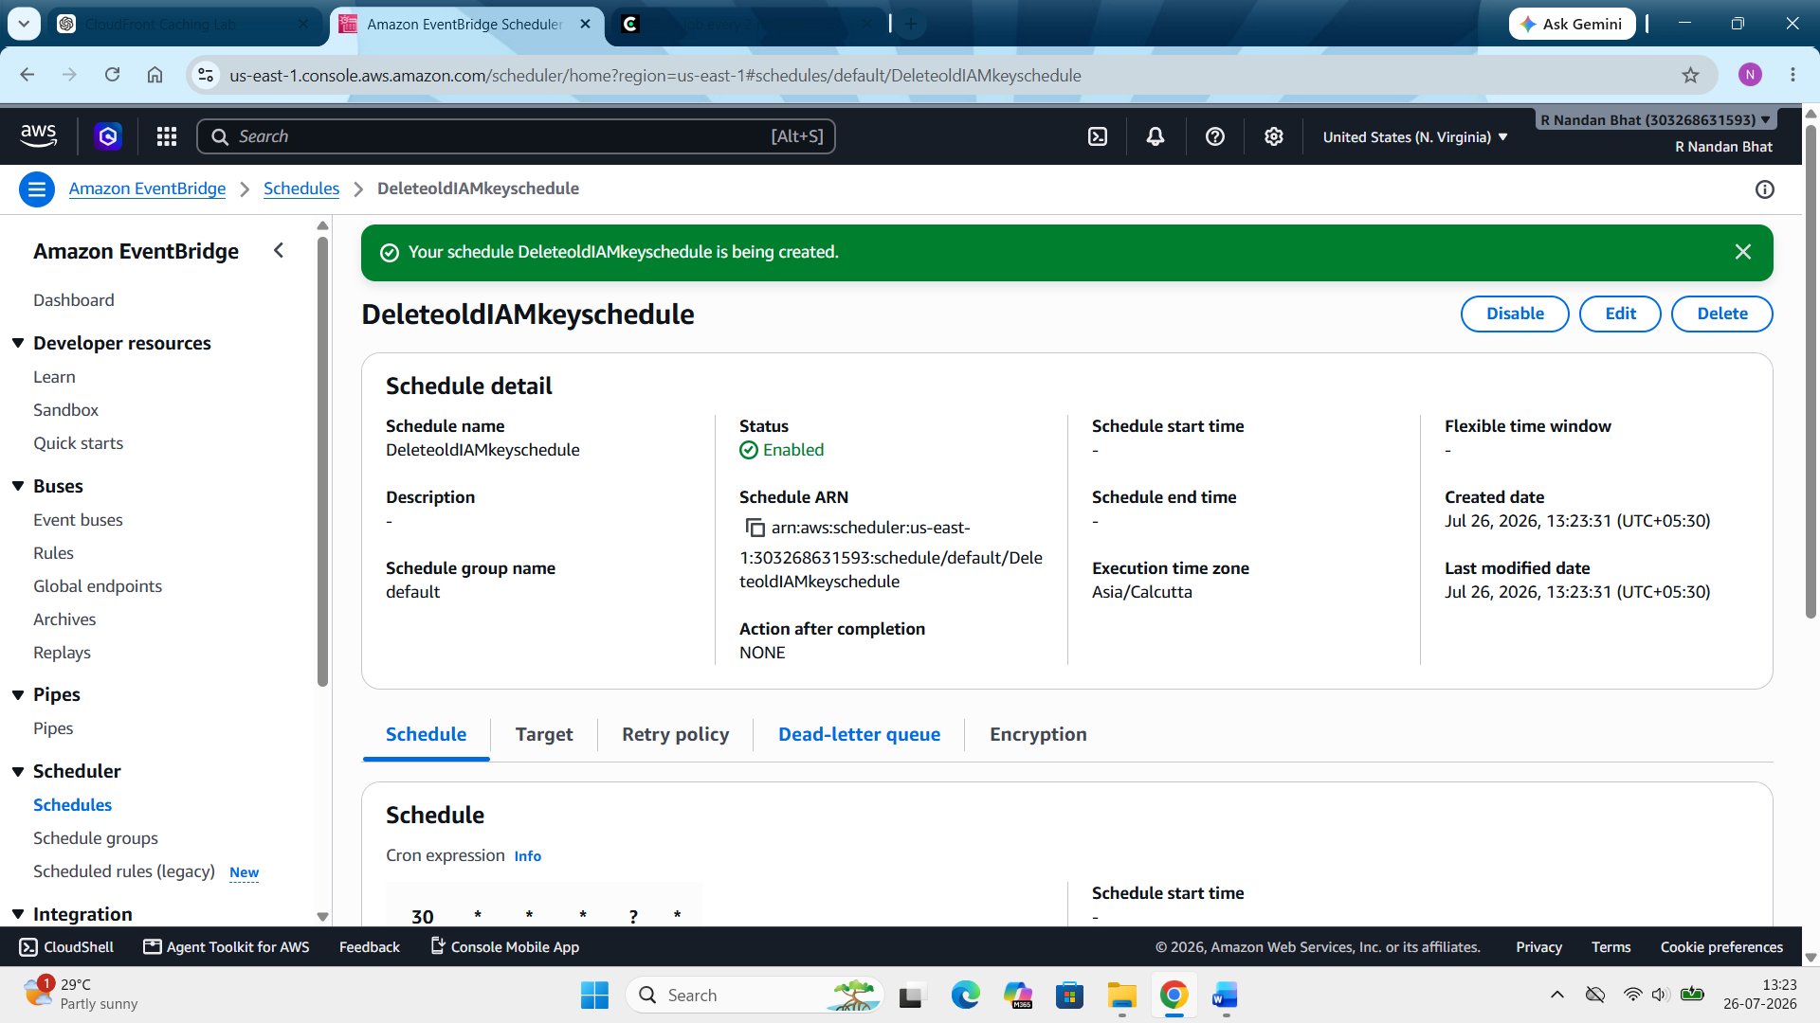
Then do the clean up as mentioned.

